4. Formal Analysis Using Alloy
4.1 Signatures
// Defines a signature Email representing email addresses.
sig Email {}
// Defines a signature DateTime with fields of type Int. The constraint ensures that the date is
// non-negative.
sig DateTime {
date: one Int,
hour: one Int,
minute: one Int,
second: one Int
} {
date >= 0 and
hour >=0 and hour < 24
minute >= 0 and minute < 60
second >=0 and second <60
}
// Signature for a programming language.
sig Language {}
// An abstract signature representing a badge.
abstract sig Badge{}
// An abstract signature representing a test case.
abstract sig TestCase{}
// Signature for a title with a name and a timestamp.
sig Title{
name: some String,
time: one DateTime
}
// An abstract signature representing a user.
abstract sig User {}
// Defines a signature Student that extends User. The constraint ensures that all battles in
// closedBattles have status Closed.
sig Student extends User {
email: one Email,
title: set Title,
closedBattles: set Battle, // student participated battles in the past time
score: set PersonalScore
}{
closedBattles.status = Closed
}
// Defines a signature Educator that extends User. The constraint ensures that both closed
// battles and closed tournaments must have the status Closed.
sig Educator extends User {
email: one Email,
closedBattles: set Battle,
closedTournament: set Tournament
}{
closedBattles.status = Closed and closedTournament.status = Closed
}
// Defines a signature Team. The constraints ensure that the number of members is between
// minMembers and maxMembers, and the sum of autoScores and manualScores is between
// 0 and 100.
sig Team {
name: set String,
minMembers: one Int,
maxMembers: one Int,
members: some Student,
battle: one Battle,
scores: one TeamScore
}{
#members >= minMembers and #members <= maxMembers and
scores.autoScores + scores.manualScores <= 100 and
scores.autoScores >= 0 and scores.manualScores >= 0
}
// Defines a signature Score. The constraints ensure that totScore is the sum of autoScores
// and manualScores, and both autoScores and manualScores are non-negative.
sig Score {
totScore: one Int,
autoScores: one Int,
manualScores: one Int
} {
totScore = autoScores + manualScores and autoScores >= 0 and manualScores >= 0
}
// Defines a signature PersonalScore that extends Score and includes references to a student
// and a tourenament.
sig PersonalScore extends Score {
student: one Student,
tournament: one Tournament
}
// Defines a signature TeamScore that extends Score and includes references to a team and
// a battle.
sig TeamScore extends Score{
team: one Team,
battle: one Battle
}
// Define a signature battle. Constraints ensure a chronological order for ongoing battles.
// Subscription time (regStartTime and regEndTime) must be earlier than the battle start time
// (begStartTime and begEndTime), and the starting time must be earlier than the ending
// time.
sig Battle {
name: set String,
regStartTime: one DateTime,
regEndTime: one DateTime,
begStartTime: one DateTime,
begEndTime: one DateTime,
tournament: one Tournament,
languages: some Language,
status: one Status,
teams: some Team,
testFile: some TestCase
}
// Define signature tournaments. Constraints ensure chronological ordering, no common
// educators between collaborators and admins, subscription times (regStartTime and
// regEndTime) must be earlier than the battle starts times (beginStartTime and begEndTime), // and the start time must be earlier than the end time.
sig Tournament {
name: one String,
regStartTime: one DateTime,
regEndTime: one DateTime,
begStartTime: one DateTime,
begEndTime: one DateTime,
awards: some Badge,
admin: one Educator,
status: one Status,
cooperator: set Educator,
battles: some Battle
}{
cooperator & admin = none
}
// Defines an abstract signature Status and two sub-signatures: Ongoing and
// Closed, representing different statuses.
abstract sig Status {}
one sig Ongoing extends Status {}
one sig Closed extends Status {}
4.2 Facts
// It is asserted that there are no instances of both a Student and an Educator with the same
// email address.
fact noSameEmailStudentAndEducator {
no disj s: Student, e: Educator | s.email = e.email
}
// Ensures that within a battle, there are no two distinct teams with the same name.
fact noDuplicateTeamInOneBattle{
all b: Battle| no disj t1, t2: b.teams | t1.name = t2.name
}
// Ensure that no two distinct teams share the same team members within a battle.
fact noDuplicateTeamMember {
all b: Battle| all disj t1, t2: b.teams | t1.members & t2.members = none
}
// Asserts that the total score of a team is the sum of the personal scores of its members for a
// specific tournament.
fact personalScoreIsSumofTeamScore {
all t: TeamScore, p:PersonalScore | p.student in t.team.members
and p.tournament = t.battle.tournament implies t.totScore = sum( p.totScore)
}
// If a battle is associated with a tournament, it will not be able to continue if the tournament
// is closed.
fact noBattleIfTournamentClosed {
all b: Battle, t: Tournament | b in t.battles implies not( b.status = Ongoing and t.status = Closed)
}
// Enforce time constraints for battles in a tournament, ensuring proper start and end times.
fact timeBattleInTournament {
all b: Battle, t: Tournament | b in t.battles implies
(isEarlier[t.begStartTime, b.begStartTime] and
isEarlier[b.begEndTime, t.begEndTime] and
isEarlier[b.regStartTime, t.begStartTime] and
isEarlier[b.regEndTime, t.begStartTime]
)
}
// Establish time constraints for battles, including the order of start and end times.
fact BattleTimeConstraints{
all b: Battle |
isEarlier[b.regStartTime, b.regEndTime] and
isEarlier[b.regEndTime, b.begStartTime] and
isEarlier[b.begStartTime, b.regEndTime] and
(b.status = Ongoing implies (b.begEndTime = none and b.begStartTime != none))

}
// Specifies the start and end times for tournaments within a given time frame.
fact TournamentTimeConstraints{
all t: Tournament |
isEarlier[t.regStartTime, t.regEndTime] and
isEarlier[t.regEndTime, t.begStartTime] and
isEarlier[t.begStartTime, t.regEndTime] and
(t.status = Ongoing implies (t.begEndTime = none and t.begStartTime != none))
}
// Defines a predicate isEarlier to compare two DateTime instances, determining if the first
// one is earlier than the second.
pred isEarlier[t1: DateTime, t2: DateTime]{
t1.date < t2.date or
(t1.date = t2.date and (t1.hour < t2.hour or
(t1.hour = t2.hour and (t1.minute < t2.minute or
(t1.minute = t2.minute and t1.second < t2.second)))))
}
// Defines a predicate show with assertions about the counts of tournaments and battles in
// various statuses.
pred show [] {
#Tournament = 2
#Battle = 2
#{b1: Battle | b1.status = Ongoing} = 1
#{b2: Battle | b2.status = Closed} = 1
#{t1: Tournament | t1.status = Ongoing} = 1
#{t2: Tournament | t2.status = Closed} = 1
}
run show for 3

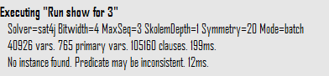
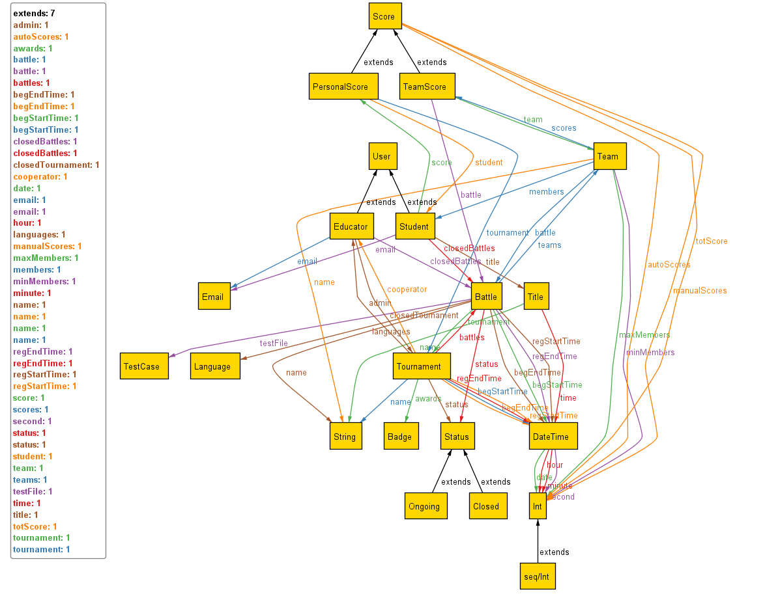

Metamodel showing the states of the tournaments and battles . It is also possible to see other constraints of the system. Such as one students cannot join two different team in same battle.

